Log in page



When user put in right user name and password then

Step1: Put into password and user name



Step2:

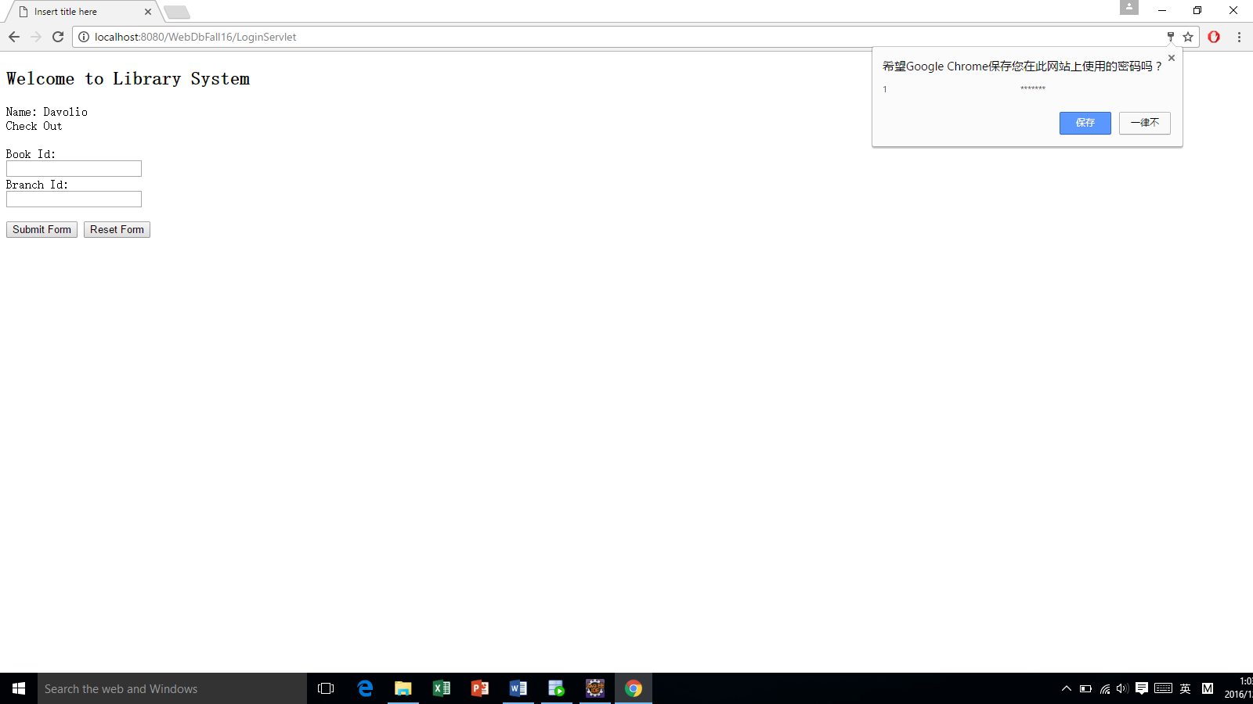

But if user log into wrong username or password

(It will come to next page to let you log in again)

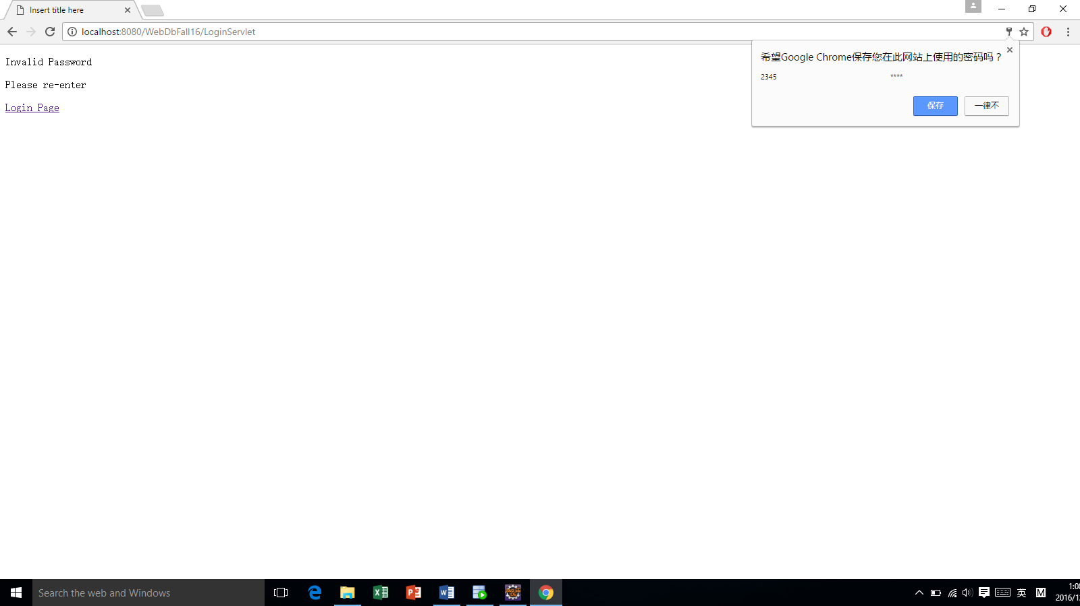

If user want to check out one book

Step 1: Put into BookID and BranchID

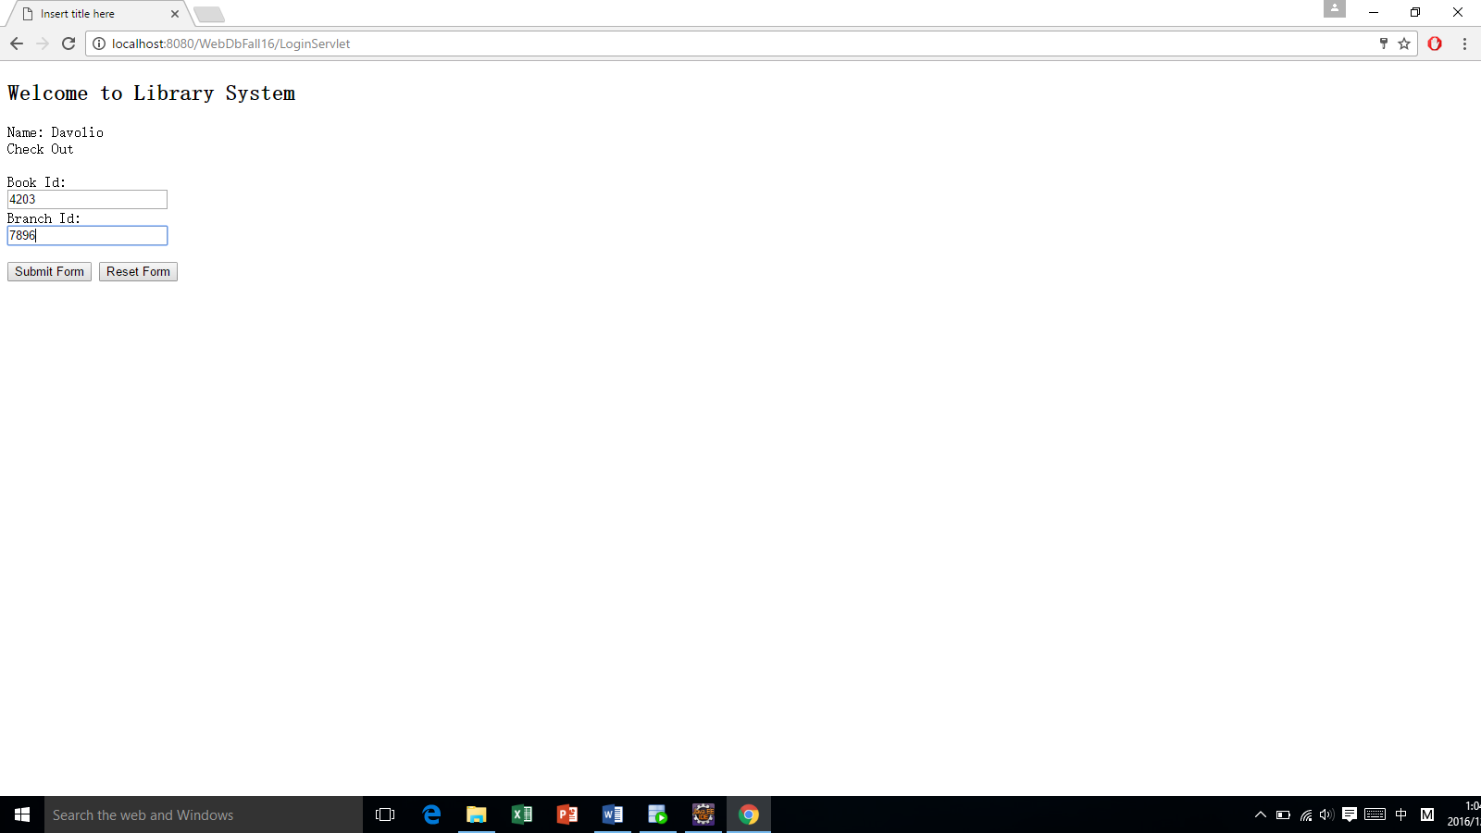

Step2: (This book already been checked out, so it’s fail to check again)

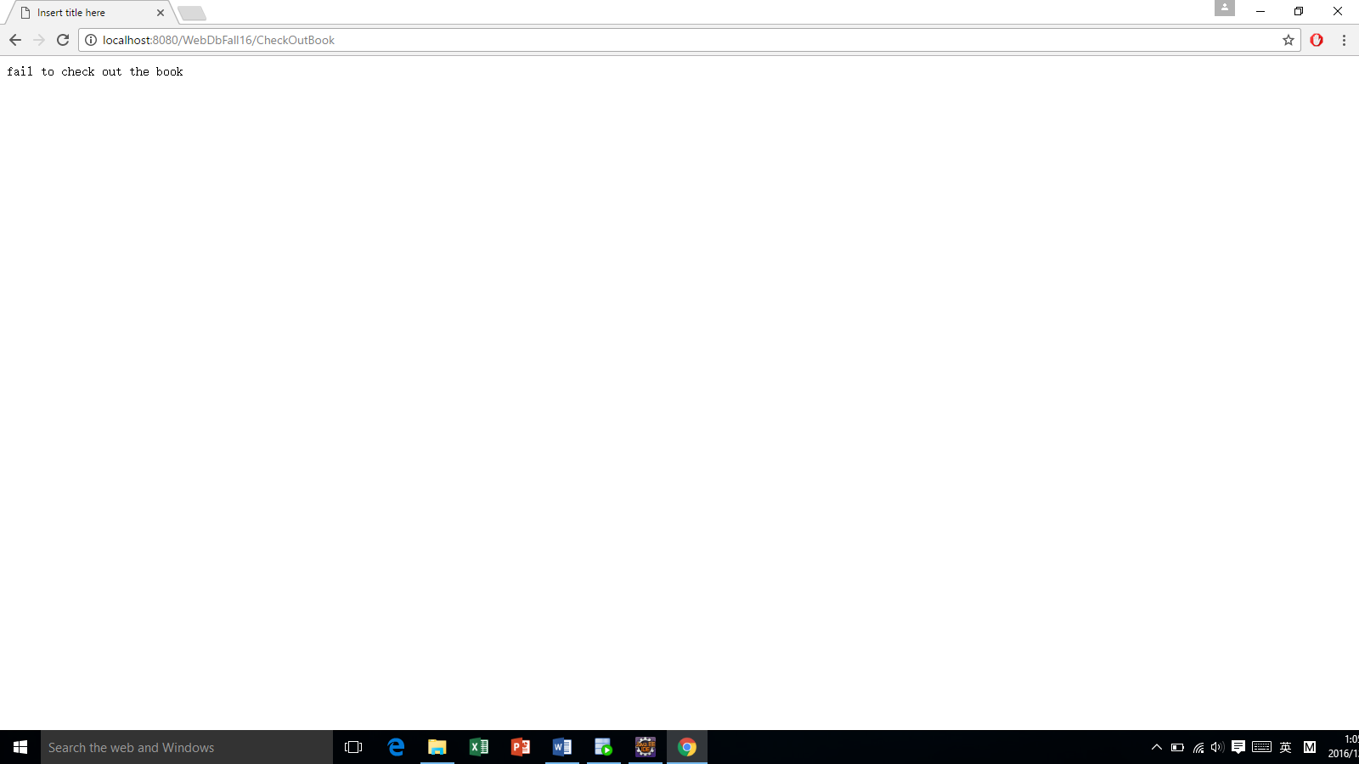

If you click on the new user button, then you will get to a new page.

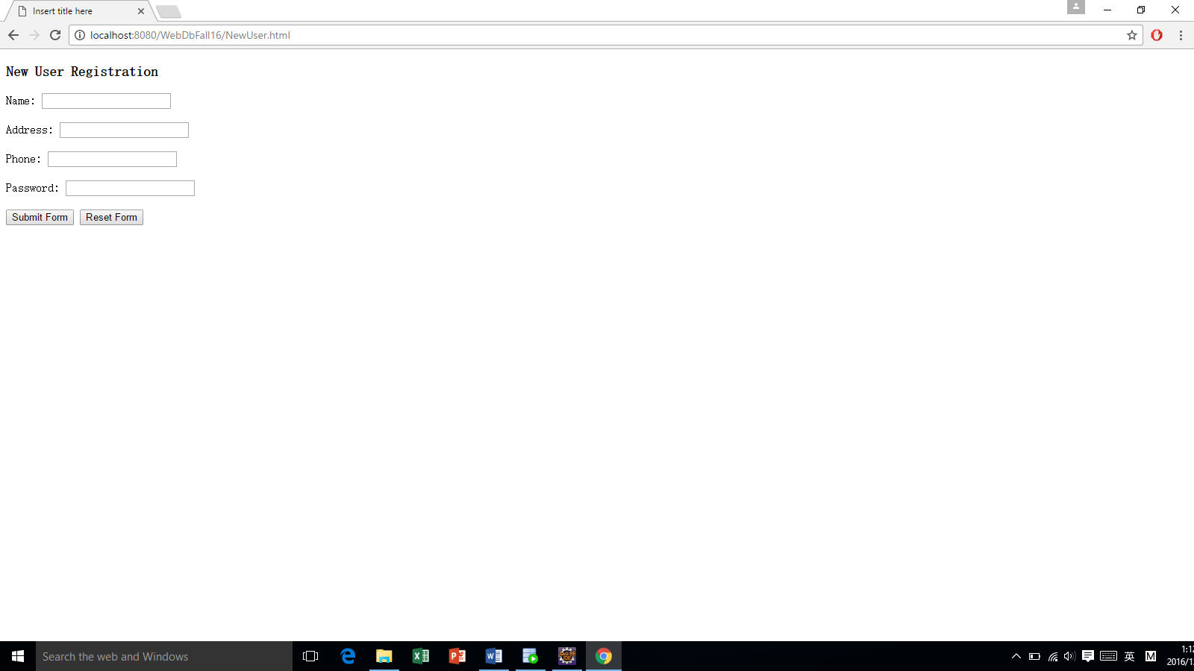

When user fills in all this massage, user click on submit button. After that, user will get a user number.

Step1, User put into their user information:

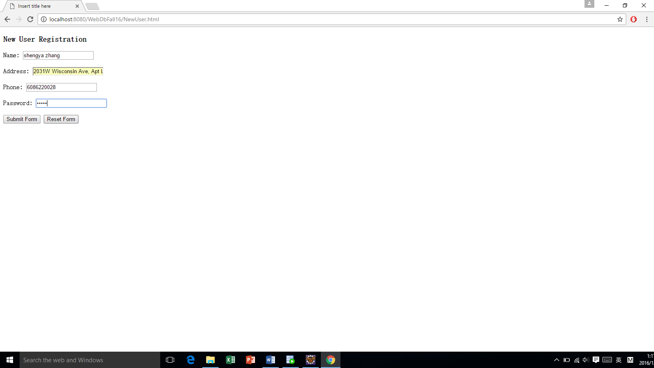

Step 2, user will get user id

